**Chapter 2 : NAZI GERMANY**

**Types of Governments**

Democracy, communism, and authoritarianism are three different forms of government that have distinct characteristics and principles.

|  |  |  |
| --- | --- | --- |
| **Government** | **Details** | **Examples** |
| Democracy | Democracy is a political system where power is held by the people or their elected representatives.  The principles of democracy are individual rights, equality, freedom of speech and expression, and the rule of law.  Citizens participate in the decision-making process through free and fair, and political decisions are made based on the majority's will. | Examples of democratic governments include the USA, United Kingdom and France. |
| Communism | Communism is an economic and political ideology that aims to create a CLASSLESS society where property and resources are owned and controlled by the government, rather than by individuals or corporations.  Communism seeks to establish a society where all people are equal and work for the common good.  In practice, communist governments have often been characterized by authoritarianism, lack of individual freedoms, and suppression of dissent. | Examples of communist governments include the USSR,, China and Cuba. |
| Authoritarianism | Authoritarianism is a form of government where power is concentrated in the hands of a single individual or a small group of individuals, and political decisions are made without the consent of the people.  In authoritarian governments, citizens do not have the right to freely express their opinions, organize politically, or participate in the decision-making process. The ruling elite maintain their power using force or coercion. | Examples of authoritarian governments include Nazi Germany, Fascist Italy and Japan**.** |

Why was Authoritarianism gaining popularity in the 1920s?

* Authoritarianism gained popularity in Germany, Italy and Japan.
* This is because citizens in these countries lost their faith in their democratic governments that were established after WW1.
* The democratic governments had failed to improve the economic conditions and peace in the country.
* Democracy appeared weak as the different political parties would be competing instead of solving the problems affecting the country.
* These democratic governments were ineffective in solving the problems caused by the Great Depression of 1929 which led to further unhappiness with this form of government.

**What you need to know from Chapter 2:**

|  |
| --- |
| **WHY DID THE NAZIS RISE TO POWER?** |

**1. Weaknesses of the Weimar Government**

The Weimar Republic faced serious weaknesses that made it unpopular and unstable. These weaknesses made it easier for extremist groups like the Nazis to gain support.

**1. Problems with the Weimar Constitution**

1. **Proportional Representation**:
   * The Weimar was composed of several political parties.
   * Each party earned seats depending on the percentage of votes garnered during the elections.
   * They had to form coalitions to govern as no one party could gain enough seats to form the majority.
   * Small parties, such as the Communists (KPD) Party could enter the government even though they did not have many votes.
   * **Impact**:
     + These parties often could not work together, and this led to slow decision making.
     + The coalition government often collapsed leading to an unstable government.
     + The government was unable to make decisions fast to improve Germans’ lives.
     + Citizens lost confidence in democracy, seeing it as chaotic and ineffective, paving the way for extremist parties such as the Nazis to promise strong, decisive leadership.
     + The Nazis exploited this instability by presenting themselves as the only party capable of restoring order and unity.-> this would make them more popular.
2. **Article 48**:
   * Article 48 - empowered the President to declare a state of emergency and seize complete control of the nation.
   * It was often used during the **Great Depression (1929-1933)** in order to make decisions fast.
   * Reichstag often could not come to an agreement hence the President made decisions using Article 48.
   * **Impact**:
     + The frequent use of Article 48 made the Weimar appear weak and citizens began to question the effectiveness of the Weimar Republic which led to growing unhappiness.
     + In 1933, Hitler would exploit Article 48 to remove his opponents from the government paving the way for him to establish a dictatorship.

**2. Unpopularity of the Weimar Government.**

1. **Blamed for the Treaty of Versailles.**
   * Germany was forced to accept full responsibility for the war ("War Guilt Clause") and pay massive reparations. -> this led to severe economic hardship.
   * Germany lost significant territories, including Alsace-Lorraine, and its overseas colonies, reducing its economic and military power.
   * Military restrictions were severe, limiting the army to 100,000 troops and banning tanks, aircraft, and submarines. - > made Germany very vulnerable to attacks
   * **Impact**:
     + The treaty was seen as a national humiliation and created anger towards the Weimar government, which had signed it.
     + Germans referred to the treaty as a "Diktat" (dictated peace) and blamed Weimar politicians, calling them the "November Criminals."
     + The Nazis would manipulate the people’s anger to win support -> they would promise the people to undo the Treaty if they voted for the Nazis.
2. **The "Stab-in-the-Back" theory**:
   * Germans believed that their army was “stabbed in the back” by the Weimar government who had agreed to the armistice.
   * Germans were proud of their once powerful army and refused to believe their army had been defeated.
   * They believed the German army had not lost the war and expected an agreement where Germany would be treated as equals.
   * Many were shocked at the terms of the treaty.
   * **Impact**:
     + This made the Weimar government more unpopular because the treaty had reduced their army strength and humiliated them.
     + Germans referred to the Weimar as NOVEMBER CRIMINALS because the Armistice was signed in November.
     + The Nazis made use of this to win more support by putting all the blame on the Weimar government.
3. **Opposition to the Weimar government**

* **Left-Wing Threats**:
  + The Spartacist Uprising (1919):
    - The Spartacists (communists) sought to establish a Soviet-style state.
    - They organized strikes and attempted to seize control of Berlin.
    - Ebert’s government relied on the Freikorps, a paramilitary group of ex-soldiers, to crush the rebellion.
    - **Impact**:
      * The violence weakened the Weimar Republic who were seen as weak and ineffective. because they needed the help of the Freikorps to stop the uprising.
      * Germans lost faith in the Weimar government as they were unable to maintain peace in the country.
      * Nazis became more popular who promised to maintain stability in the country.
* **Right-Wing Threats**:
  + The Kapp Putsch (1920):
    - Led by Wolfgang Kapp and supported by the Freikorps, this coup aimed to overthrow the Weimar government and restore authoritarian rule.
    - The army refused to listen to the Weimar government to stop the Putsch.
    - However, the Kapp putsch failed as Germany’s trade union and civil servants supported the government and went on strike.
    - A general strike by workers and unions paralyzed the country, forcing Kapp to flee.
    - **Impact**:
    - The instability and violence made the Weimar government look weak and unpopular as they were seen as incapable of maintaining law and order.
      * Nazis became more popular who promised to maintain stability in the country.

**3. Economic Challenges**

* **Hyperinflation (1923)**:
  + Following World War 1, Germany had economic difficulties.
  + It was forced to pay substantial reparations to the Allies.
  + In 1922 – the Weimar was unable to pay reparations due to economic hardships.
  + The French and Belgians sent 60,000 soldiers into the Ruhr region of Germany to force Germany to pay. They took resources and goods as payment.
  + The Weimar instructed Ruhr workers to go on strike instead of helping the French and Belgians.
  + The Weimar printed more money, but this led to the fall in the value of the currency.
  + This led to **hyperinflation.**
  + Overnight people’s money became worthless. -> their life savings wiped out.
  + Sharp increase in the price of goods – For e.g. a loaf of break cost 200,000 marks in 1923 (from 250 marks)
  + **Impact**:
    - Hyperinflation caused great hardship and poverty.
    - It made people very angry with the Weimar and blamed them for the crisis.
    - Germans lost faith the Weimar and turned towards other parties such as the Nazis who promised to solve the economic problems.

**2. Appeal of the Nazi Party**

The Nazis gained support through Hitler’s leadership, propaganda, and the use of violence and intimidation.

**1. Role of Hitler**

**a. Hitler’s Charisma and Oratorical Skills**

* Hitler was an excellent public speaker who could engage and inspire crowds.
* He delivered passionate speeches that made him appear strong and decisive.
* He connected with ordinary Germans, making them feel he understood their struggles.
* He exploited the situation to his advantage by blaming the Weimar for the Germany’s economic problems
* **Impact:** 
  + Many Germans saw Hitler as a leader who could restore Germany’s strength and pride.
  + He was able to win the confidence of Germans, business owners and industrialists because he was anti-communist -> they donated to his Nazi party which then able to continue to win support for themselves.
  + His efforts would help the Nazis gain more than 100,000 members by 1929.

**b. Reorganising the Nazi Party**

* After the failed Munich Putsch (1923), Hitler decided to gain power legally through elections.
* He wrote Mein Kampf, outlining Nazi beliefs:
  + Destroy the Treaty of Versailles.
  + Expand Germany (Lebensraum).
  + Create a strong central government.
* Hitler strengthened control over the Nazi Party and expanded its local branches.
* **Impact**:
  + The Nazis became **better organised** and gained more supporters, allowing them to increase their votes in elections.
  + Expanding local branches meant that the Nazis could reach out to more Germans and convince them to support the Nazis.

**2. Methods Used by the Nazi Party**

**a. Use of Propaganda**

* Joseph Goebbels led Nazi propaganda, spreading their message through:
  + Radio, newspapers, leaflets, and posters.
  + Nuremberg Rallies to showcase Nazi strength.
* Propaganda blamed Jews, communists, and Weimar politicians for Germany’s problems.
* Propaganda blamed the Weimar for not doing enough to help Germans with the economic problems such as unemployment.
* Propaganda blamed the Jews for being selfish and not caring for the plight of Germans.
* Propaganda portrayed the Nazis as the only group capable of strengthening Germany and solving Germans’ problems.
* **Impact**:
  + Many Germans believed the Nazi message and saw Hitler as their savior.
  + Won the confidence of Germans as the Nazis appeared to understand Germans and address their problems.
  + Rich industrialists and business owners supported the Nazis by providing money which enabled them to continue their election campaigns.
  + Nazis won more support.

**b. Role of SA and SS**

* The SA (Brownshirts) and the SS (Blackshirts)
  + Hitler’s private army and personal body guards respectively.
  + They were an elite force completely loyal to Hitler.
  + As there were regular street battles in Germany in the 1920s, they would help to maintain law and order in the country by working with the police.
* They were used to fight the communists and break up their meetings. -> This won the support of many Germans who were worried about the growing popularity of Communism.
* **Impact**:
  + Many Germans admired the discipline and order of the Nazis.
  + Germans viewed the Nazis as a disciplined and strong party and this won their confidence.
  + Germans believed the Nazis could help restore order and strengthen Germany.
  + Many Germans began to support the Nazis.

**3. Impact of the Great Depression**

The Great Depression (1929) devastated Germany’s economy, increasing Nazi support.

**a. Unemployment – Germans suffered**

* The Wall Street Crash (1929) led to a global economic crisis.
* US banks recalled their loans they gave Germany and removed their investments in Germany -> this led to the collapse of the German economy.
* By 1932, six million Germans were unemployed (nearly 40% of the workforce).
* Many businesses closed down, and families struggled to survive
* Many suffered from reduced incomes and poverty.
* Impact:
  + People lost faith in the Weimar government, which failed to take effective action.
  + The Nazis promised jobs and economic recovery, making them more popular.

**b. Failure of Democracy – Weimar became more unpopular.**

* The Great Depression made the Weimar Republic unpopular as they were unable to resolve the effects of the Depression.
* The Social Democrats (SPD) wanted to increase unemployment benefits, while other parties wanted to cut spending.
* President Hindenburg used Article 48, allowing him to make decisions without the approval of the Reichstag. -> his decision to appoint HEINRICH BRUNING as Chancellor was unpopular as Bruning wanted to cut the salaries of civil servants.
* **Impact**:
  + The regular use of Article 48 proved to Germans that democracy was ineffective in solving Germany’s problems.
  + The Nazis promised to end the ineffective democratic system of the Weimar, and this would win them more support.

**c. Fear of Communism**

* The Communist Party (KPD) gained support as workers turned to communism.
* Middle-class Germans, business owners, and landowners feared a communist revolution.
* Nazis used propaganda to spread fear, claiming communists would:
  + Seize businesses and land.
  + Ban religion.
  + Destroy German traditions.
* **Impact**:
  + Many Germans saw Hitler as the only leader who could stop communism.
  + Wealthy business owners funded the Nazis, helping them grow stronger.
  + The SA fought communists in the streets, increasing Nazi popularity.

**Nazis used the Great Depression to their benefit.**

* The Great Depression was exploited ruthlessly and effectively by the Nazis which enabled them to increase in popularity. By 1933 they had more than 800,000 members,
* People became more willing to support the Nazis as they had lost faith in the Weimar Republic.
* The Nazis promised people to solve the economic crisis by providing jobs and improving their lives. They criticized the Weimar’s poor handling of the crisis which further discredited the Weimar.

**Part 2 – Consolidation of Nazi Rule and Life during Nazi**

**Part 2 – Consolidation of Nazi Rule and Life during Nazi**

**Hitler was appointed Chancellor in 1933. From then on, he began consolidating his power.**

**1. Establishing Hitler’s Dictatorship and One-Party Rule**

**a. Reichstag Fire**

* On 27 February 1933, the Reichstag building was set on fire. The Nazis blamed a Dutch communist, Marinus van der Lubbe, claiming it was the start of a communist uprising.
* Hitler used the event to spread fear of a communist revolution and convinced President Hindenburg to pass the Decree for the Protection of People and State.
* This decree suspended civil liberties, such as freedom of speech, assembly, and the press. It also allowed for indefinite detention without trial.
* Over 4,000 communists were arrested on the night of the fire, and many opposition newspapers were banned.
* **Impact**:
  + The Reichstag Fire allowed the Nazis to suppress political opposition and create an atmosphere of fear.
  + By eliminating the communists, Hitler reduced competition for votes in the upcoming elections, strengthening his hold on power.
  + In the 1932 elections, it enabled the Nazis to obtain 52% of the seats in the Reichstag which gave them a majority.

**b. Enabling Act**

* Passed on 23 March 1933, the Enabling Act allowed Hitler to make laws without consulting the Reichstag or the President.
* The Nazis intimidated other parties into supporting the act, with the SA and SS present during the vote to create fear.
* Communists were banned from voting, and the Catholic Centre Party was persuaded to support the act with promises to protect church interests.
* **Impact**:
  + The passing of this law made Hitler into a dictator and ended democracy.
  + It increased Hitler’s control over Germany as he could now create new laws to eliminate his opposition and establish total control.

**c. Gleichschaltung (Coordination)**

* Gleichschaltung was the process of bringing all aspects of German society under Nazi control.
* Trade unions were banned in May 1933, replaced by the German Labour Front (DAF), which ensured workers could no longer strike or negotiate for better wages.
* Local councils and state governments were taken over by Nazi officials, ensuring uniformity across Germany.
* Political parties were banned in July 1933, making the Nazi Party the sole legal political organization.
* **Impact**:
  + Gleichschaltung eliminated political opposition and centralized power in the hands of the Nazis.
  + By controlling local governments, trade unions, and other institutions, the Nazis ensured loyalty and reduced the chances of opposition.

**d. Night of the Long Knives**

* In June 1934, Hitler ordered the SS to purge the leadership of the SA, including its leader Ernst Röhm, who was seen as a threat.
* Rohm’s ideas of taxing the rich made the elites worried.
* Röhm’s desire to merge the SA with the army worried the army.
* Over 400 individuals, including former political opponents and SA leaders, were executed.
* **Impact**:
  + The purge secured the support of the army, as they viewed the SA as a rival force.
  + It eliminated internal threats within the Nazi Party, consolidating Hitler’s absolute authority.
  + Many Germans viewed Hitler as a decisive leader willing to take tough actions to ensure stability.

**e. Army and the Oath of Allegiance**

* After President Hindenburg’s death on 2 August 1934, Hitler declared himself Führer, combining the roles of Chancellor and President.
* The entire German army swore an oath of personal loyalty to Hitler.
* Hitler expanded the army through rearmament and introduced conscription in 1935, strengthening its capacity.
* **Impact**:
  + The oath ensured the loyalty of the military, removing a potential source of opposition to Hitler’s rule.
  + By investing in the military, Hitler gained the support of officers and boosted national pride, solidifying his dictatorship.

**2. Nazi Economic Policies**

**a. Economic Recovery and Unemployment**

* Germany faced severe unemployment during the Great Depression, with over six million unemployed in 1932.
* The Nazis introduced massive public works programs, such as building autobahns (highways), railways, and public buildings.
* The Reich Labour Service (RAD) required young men to work on these projects, reducing unemployment.
* Hitler appointed Hjalmar Schacht as President of the Reichsbank and later as Economics Minister. Schacht’s policies stabilized Germany’s finances and funded work creation through deficit spending.
* **Impact**:
  + Unemployment dropped significantly, creating a sense of economic recovery and stability under Nazi rule.
  + People’s lives improved as they now had a means to earn an income and escape the hardships caused by the Great Depression.
  + The programs boosted public morale and increased support for Hitler, as many Germans credited him with saving the economy.

**b. Rearmament and Move to a War Economy**

* Rearmament was a key goal for Hitler, both to restore Germany’s military strength and to reduce unemployment.
* In 1935, conscription was reintroduced, and the army was expanded.
* The Four-Year Plan, launched in 1936 under Hermann Göring, aimed to make Germany self-sufficient (autarky) and prioritize rearmament.
* Industries shifted to producing weapons, vehicles, and other military supplies.
* **Impact**:
  + Rearmament created jobs and strengthened Germany’s economy, increasing national pride and support for Hitler.
  + It prepared Germany for war, aligning with Hitler’s expansionist goals.

**c. Living Standards in Nazi Germany**

* Big businesses benefitted from government contracts, and managers saw significant income increases.
* Farmers were supported by debt relief laws, but many remained poor as their farms were effectively owned by the state.
* Middle-class Germans appreciated the crushing of communism but faced challenges in running small businesses due to the focus on large industries.
* **Impact**:
  + While some groups benefited, others experienced limited improvement in living standards, leading to mixed feelings about Nazi policies.

**d. Working Conditions in Germany**

* Programs like Strength Through Joy (KdF) offered workers leisure activities, cheap vacations, and entertainment. -> sports, overseas trips, cheap cinema tickets were offered.
* The Beauty of Labour movement aimed to improve factory conditions, such as adding canteens and washing facilities.
* Workers lost their trade unions but were forced to join the German Worker’s Front (DAF). -> Wages were kept low.
* **Impact**:
  + KDF and Beautify of Labour were popular with Germans as they now had access to activities which they could not afford in the past. -> Won more support for the Nazis.
  + However, workers lost their rights to ask for higher wages and the long working hours were unpopular. They were also not allowed to change jobs.

**3. Social Policies**

**a. Role of Women**

* Women were encouraged to focus on their roles as mothers and homemakers, with campaigns promoting the “Three Ks” (Kinder, Küche, Kirche – Children, Kitchen, Church).
* The Mother’s Cross was awarded to women who had many children, promoting large families.
* Women were excluded from politics and discouraged from higher education and employment.
* Young girls had to attend courses in the League of German Girls to learn domestic chores.
* During the later war years, women were recruited into the workforce to support the war effort.
* **Impact**:
  + Some women supported the Nazis as they agreed with the Nazis view that women should stay home and take care of the family.
  + However, many were unhappy as they felt oppressed as they were unable to establish a career. They felt their freedom was restricted and were forced to follow the Nazi policies.

**b. Education and the Hitler Youth**

* Schools were controlled by the Nazi regime, with a curriculum emphasizing Nazi ideology, racial superiority, and loyalty to Hitler.
* History and biology were used to promote Nazi values, and textbooks were rewritten to reflect their ideology.
* The Hitler Youth and League of German Girls provided paramilitary training, sports, and Nazi indoctrination for young people.
* By 1933, there were 2.3 million members in the Hitler Youth and by 1936 it became compulsory.
* **Impact**:
  + Created a generation deeply loyal to the Nazi regime, ensuring future support for its policies.
  + Some youths enjoyed the activities and became loyal to the Nazis.
  + Some did not support these policies as they were unhappy with the loss of freedom -> they formed anti Nazi groups such as the White Rose.

**c. Persecution of Minorities**

* Groups such as the Roma, disabled people, and homosexuals were targeted through sterilization programs, euthanasia, and imprisonment in concentration camps.
* The Nazis believed in creating a “master race” and used eugenics to eliminate those they deemed inferior.
* **Impact**:
  + These policies caused immense suffering and death, while reinforcing Nazi racial ideology and fear among the population.

**d. Hitler and the Jews**

* Hitler hated the Jews - > he also blamed them for all the sufferings felt by the Germans after WW1.
* Propaganda was used to generate anti-Semitic feelings among Germans -> by showing how sly and scheming Jews were.
* He differentiated Jews by forcing them to wear the Star of David and Jewish businesses had to display this outside their shops.
* Jews were not allowed to work in the government.
* 1935 – Nuremberg laws were created -> to further discriminate the Jews. They were not allowed to marry pure Germans, and their German citizenship was revoked.
* Kristallnacht (1938) marked a turning point, with widespread violence against Jews and their properties. -> The SS destroyed Jewish businesses and murdered many Jews. Thousands were arrested and sent to concentration camps.
* The Holocaust during World War II led to the systematic genocide of six million Jews.
* **Impact**:
  + Jews suffered greatly during Nazi rule.
  + More than 6 million Jews will die during the Holocaust.

**4. Use of Control and Fear**

**a. The SS**

* Led by Heinrich Himmler, the SS was responsible for destroying opposition and implementing racial policies.
* The Gestapo (Secret State Police) could arrest and imprison people without trial, creating a climate of fear.
* **Impact**:
  + The SS and Gestapo ensured obedience and eliminated dissent, making resistance almost impossible.
  + People lived in constant fear and they dare not oppose the Nazis.
  + This enabled the Nazis to maintain control over Germany.

**b. Concentration Camps**

* Initially used to imprison political opponents, camps later housed Jews, Roma, and other minorities.
* Prisoners endured forced labour, starvation, and executions.
* More than 1.3 million Germans were sent to concentration camps.
* **Impact**:
  + The camps silenced opposition and demonstrated the consequences of resisting the regime, spreading fear among the population.
  + It would ensure the Nazis maintained control over Germany.

**c. The Legal System**

* Judges were required to join Nazi organizations and deliver rulings aligned with Nazi policies.
* Hitler abolished trial by jury, centralizing judicial power with Nazi-appointed judges.
* The police force was controlled by the Nazis – Heinrich Himmler became chief of police which made it part of the SS.
* **Impact**:
  + The legal system became a tool for oppression, ensuring that opponents had no legal recourse and justice served the Nazi regime.
  + Opponents to the Nazis would not receive a fair trial and would often be found guilty
  + These measured ensured the Nazis strengthened their control over Germany.

**5. Use of Propaganda and Censorship**

* Joseph Goebbels, as Minister for Public Enlightenment and Propaganda, controlled all media, including newspapers, radio, films, and books.
* Propaganda glorified Hitler, promoted nationalism, and spread anti-Semitic and anti-communist messages.
* Mass rallies such as the Nuremberg rallies were organised.
* The Nazis censored opposing views, banning books and monitoring information.
* Movies had to be pro-Nazi and all anti-Nazi materials were banned.
* Cheap radios were sold to Germans to listen to Nazi propaganda. -> Foreign radio stations were banned.
* **Impact**:
  + Propaganda shaped public opinion and increased support for the Nazis.
  + People saw Hitler as the saviour and that the Nazis were the only party capable of strengthening Germany.
  + Mass rallies made people proud of Germany as they could witness the strength of Germany.
  + Anti-Jewish propaganda led to people believing the Jews needed to be punished.
  + Censorship suppressed dissent, ensuring only the Nazi message was heard.
  + These efforts would enable the Nazis to strengthen their control over Germany.

**6. Resistance and Opposition**

**a. Political Opposition**

* Socialists and communists resisted through secret meetings, strikes, and spreading anti-Nazi messages.
* Many were arrested, tortured, or executed by the Gestapo.
* **Impact**:
  + Political opposition was largely crushed, allowing the Nazis to maintain control without significant challenges.

**b. Anti-Nazi Youth Groups**

* Groups like the White Rose and Edelweiss Pirates resisted Nazi indoctrination and policies, distributing anti-Nazi leaflets or engaging in sabotage.
* Members were often arrested and executed.
* **Impact**:
  + Highlighted that not all Germans supported the Nazis, but their influence was limited due to severe repression.

**c. Religious Opposition**

* Some church leaders, like Martin Niemöller, spoke out against Nazi policies, particularly on euthanasia and racial persecution.
* Many were imprisoned or silenced by the regime.
* **Impact**:
  + Religious opposition showed moral resistance but had little impact on the Nazi regime due to the atmosphere of fear and suppression.

**Was Nazi Rule Beneficial for All People Living in Germany?**

| **Groups** | **Beneficial** | **Not Beneficial** |
| --- | --- | --- |
| Communists and other political parties |  | They were oppressed, with leaders imprisoned, executed, or exiled. |
| German army | Yes, the army benefited from rearmament and gained prestige under Nazi policies. |  |
| German farmers | Partially, farmers received debt relief and government support but were heavily controlled. | Many farmers struggled economically despite government intervention. |
| German middle-class workers | Partially, they appreciated economic stability but faced limited wage growth and strict controls. | Faced long working hours, could not strike or ask for better wages. |
| German big businesses | Yes; big businesses thrived due to government contracts and war production. | But smaller businesses struggled due to the focus on large-scale industry. |
| German women | Some were happy -> Women were encouraged to focus on motherhood. | Women lost personal freedoms and were forced into traditional roles. |
| German youths | Partially, indoctrinated through education and Hitler Youth programs, but some resisted Nazi control. | Some youths resented strict control and formed resistance groups like the Edelweiss Pirates. |
| Minority groups (such as the Roma and disabled) |  | Faced severe persecution, sterilization, euthanasia programs, and imprisonment. Targeted as inferior, leading to immense suffering and death. |
| Jews |  | Faced systemic discrimination, violence, and genocide. subjected to systemic persecution, including the Holocaust, which led to the death of six million Jews. |

**Bonus Essay Question**

**Why Did the Nazis Implement the Nuremberg Laws in 1935?**

The Nazis introduced the Nuremberg Laws in 1935 to discriminate against Jews and remove them from German society. These laws made it legal to strip Jews of their rights and exclude them from daily life in Germany.

**Reason 1: To Take Away Jewish Rights and Exclude Them from German Society**

✅ **Point:** One key reason the Nazis introduced the Nuremberg Laws was to **exclude Jews from German society and take away their rights**.

🔎 **Evidence:** The Nuremberg Laws **stripped Jews of their German citizenship**, which meant they had **no legal rights**. They were **banned from government jobs, education, and many professions**, and later **Jewish children were removed from schools (1938)**.

💡 **Explanation:** These laws made Jews **outsiders in their own country** and prevented them from living a normal life. The Nazis spread propaganda claiming that Jews were **"sub-human"** and did not belong in Germany. By passing these laws, the Nazis **legally separated Jews from German society**, making it easier to **increase discrimination and persecution later**.

🔗 **Link:** The Nuremberg Laws allowed the Nazis to **completely exclude Jews** from public life and lay the foundation for harsher actions against them in the future.

**Reason 2: To Create a “Pure” Aryan Race.**

✅ **Point:** Another reason for the Nuremberg Laws was to **promote Nazi racial ideology and remove those they saw as "impure."**

🔎 **Evidence:** Hitler and the Nazis believed in the **superiority of the Aryan race** and saw Jews as a **threat to German purity**. The Nuremberg Laws **banned marriages and relationships between Jews and Germans** to prevent what the Nazis called "racial pollution." This was part of their larger plan to create a "racially pure" German society.

💡 **Explanation:** The Nazis wanted to **control who could be part of German society** by using race as a way to decide who had rights. The Nuremberg Laws were the **first step towards complete Jewish persecution**, leading to **more extreme measures** like **Kristallnacht in 1938** and eventually the **Holocaust**.

🔗 **Link:** By legally defining who was considered "German," the Nazis **reinforced their racist beliefs** and justified further discrimination and violence against Jews.

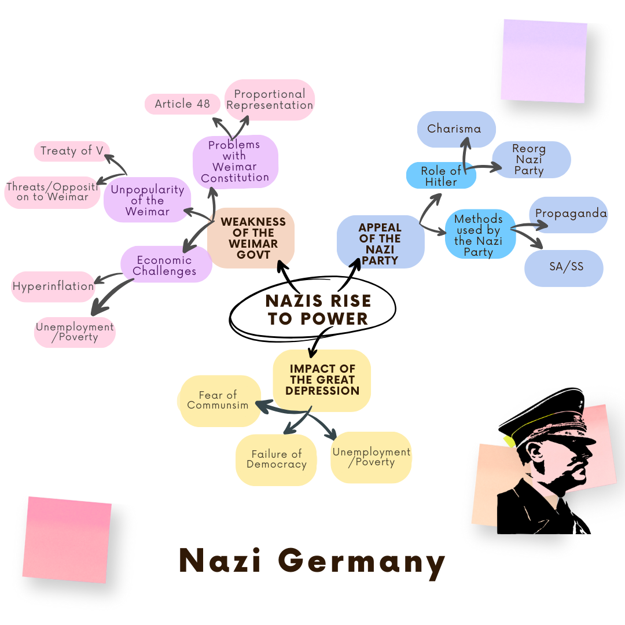

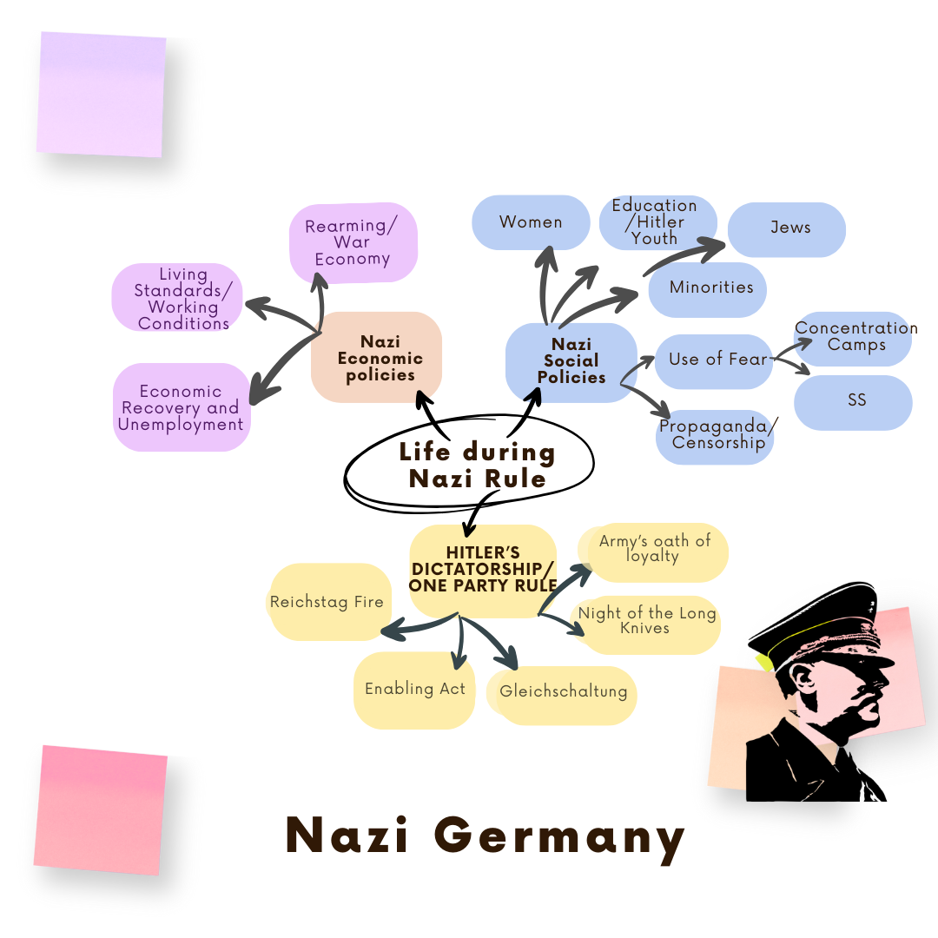

**Why Did the Nazis Implement the Nuremberg Laws in 1935?**

The Nazis introduced the Nuremberg Laws in 1935 to discriminate against Jews and remove them from German society. These laws made it legal to strip Jews of their rights and exclude them from daily life in Germany.

**Reason 1: To Take Away Jewish Rights and Exclude Them from German Society**

* Jews lost their German citizenship – they were no longer considered citizens and had no legal rights.
* Jews and Germans were not allowed to marry or have relationships – The Law for the Protection of German Blood and Honour banned marriages between Jews and Germans.
* Jews were banned from certain jobs – They could not work as government officials, teachers, or doctors.
* Jews were banned from running businesses – Germans were discouraged from buying from Jewish-owned shops.
* Jewish children were later banned from schools (1938) – They were no longer allowed to study in German schools.
* Jews were portrayed as outsiders – The Nazis spread propaganda claiming that Jews were "sub-human" and did not belong in Nazi Germany.

The Nuremberg Laws were a key step in isolating Jews from the rest of society, making it easier for the Nazis to increase their persecution later.

**Reason 2: To Create a “Pure” Aryan Race and Remove Jews from Society**

* Hitler believed in the superiority of the Aryan race – He saw Aryans (especially Germans) as the “master race” and wanted to remove those he viewed as inferior.
* The Nazis saw Jews as a threat – They wrongly blamed Jews for Germany’s problems and wanted to eliminate them.
* The Nuremberg Laws were the first step toward removing Jews – The Nazis made it harder for Jews to work, study, or live normally in Germany.
* It led to more violent actions against Jews, such as Kristallnacht (Night of Broken Glass) on 9 November 1938 – The SS organized violent attacks on Jewish homes, businesses, and synagogues.

The Nuremberg Laws were the foundation for the Nazis’ future actions, leading to widespread persecution and eventually the Holocaust.